2008年我们做了什么？
What We Have Done in 2008

2008年主要活动的简要图片报告
A brief pictorial report of CAPN main events in 2008


source: news.sina.com.cn/s/2005-02-08/15305817807.shtml

亲爱的朋友, 感谢您关注支持我们的工作，春节即将到来，我们在此奉上本报告，便于您了解我们在08年的为动物保护作出的努力，也借这个机会祝愿您新春愉快。

Dear Friends, thanks for your concern for animal protection in China, 26 is Chinese new year, the spring festival, we wish you all the best in the new Chinese year, this is a brief report outlining our main effort in animal protection in 2008

中国动保网包含下面几个下属项目,我们全部在义务基础上工作
CAPN is consistent of following projects, we all working on the volunteer basis.
 |  |  | 
伴侣动物保护网络 | 动物权利在中国 | 长春动物保护网络 | 素食主义先锋
目录Table of content
拒吃猫狗肉网络签名数量达6万 2
我们首次将世界实验动物日引入中国 2
我们组织世界动物周活动呼吁“减少肉食” 这是中国动物保护组织的第一次全国范围的关怀农场的宣传教育活动 3
我们组织了纪念世界无肉日的活动 4
我们首次在国内启动了2个动物保护主题的免费电脑游戏 5
我们启动了ARC中文动保小百科——专业的动物保护电子书, 我们的研究员已经完成了100条左右的条目 6
参与国内国际动物保护会议 7
Our online petition against consumption of cat meat and dog meat collected 60,000 signatures
we introduce world lab animal day to China for the first time
we organized world animal week called for reduce meat consumption, its first
national event for farm animal organized by Chinese animal organization
we commemorated International Meatless Day
we launched first two Chinese computer games for animal protection
we launched APpeida, a free encyclopaedia for animal protection
we have taken part in national and international conference

拒吃猫狗肉网络签名数量达6万
Our petition against consumption of cat meat and dog meat collected 60,000 signature

活动详情more information http://www.ccapn.ngo.cn/acpetition.php

我们首次将世界实验动物日引入中国
We introduced WLAD to China for the first time
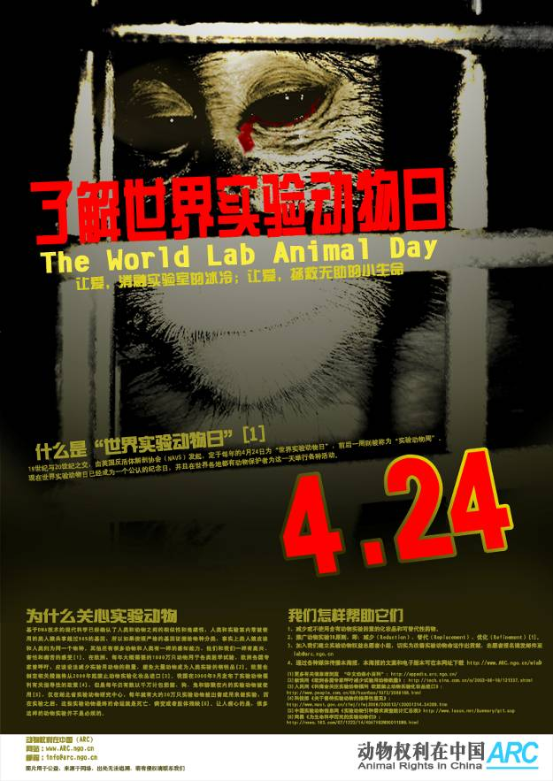
海报The poster
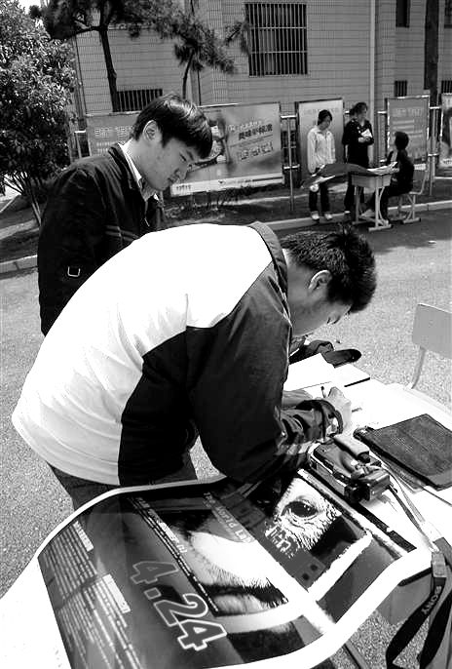
本活动详情Detail of the event:: http://www.arc.ngo.cn/wlad
English report: http://www.capn.ngo.cn/WLAD2008China_en.doc

我们组织世界动物周活动呼吁“减少肉食” 这是中国动物保护组织的第一次全国范围的关怀农场的宣传教育活动
we organized world animal week with the main message of 'reduce meat consumption', this is the first nationwide educational event for farm animal protection that is organized by Chinese animal protection organizations.
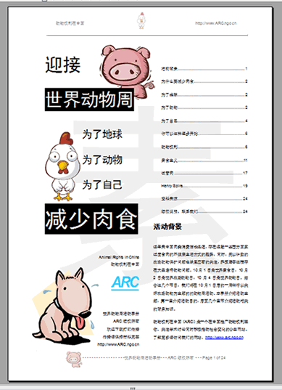
活动手册The educational booklet
行为艺术表演 performance arts show

活动详情Detail of the event: http://www.arc.ngo.cn/waw

我们组织了纪念世界无肉日的活动
We commemorated the International Meatless day

活动手册The Education Booklet
Detail of the event: http://www.povchina.ngo.cn/imd

我们首次在国内启动了2个动物保护主题的免费电脑游戏
We launched two free educational computer games, those two are first two chinese computer games for animal protection
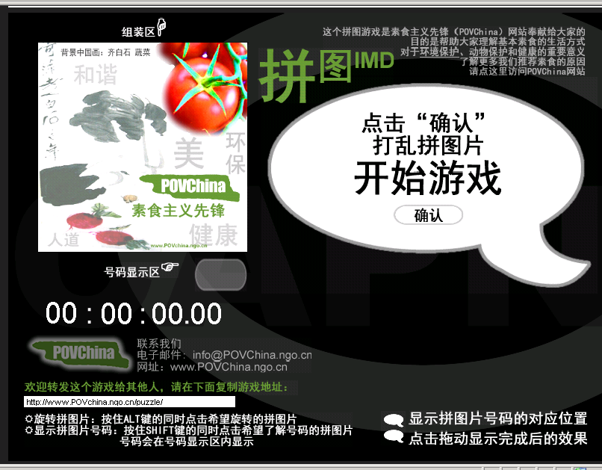
游戏1 拼图IMD Screencut of game1 Puzzle IMD
访问这个游戏acess the game http://www.povchina.ngo.cn/puzzle


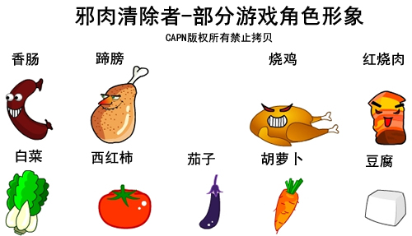
游戏2邪肉清除者IMD Screencut of game2 Meat Eraser
访问这个游戏acess the game http://www.povchina.ngo.cn/emc

我们启动了ARC中文动保小百科——专业的动物保护电子书, 我们的研究员已经完成了100条左右的条目
We launched APpedia, a free encyclopaedia for animal protection; our researchers have completed about 100 articles

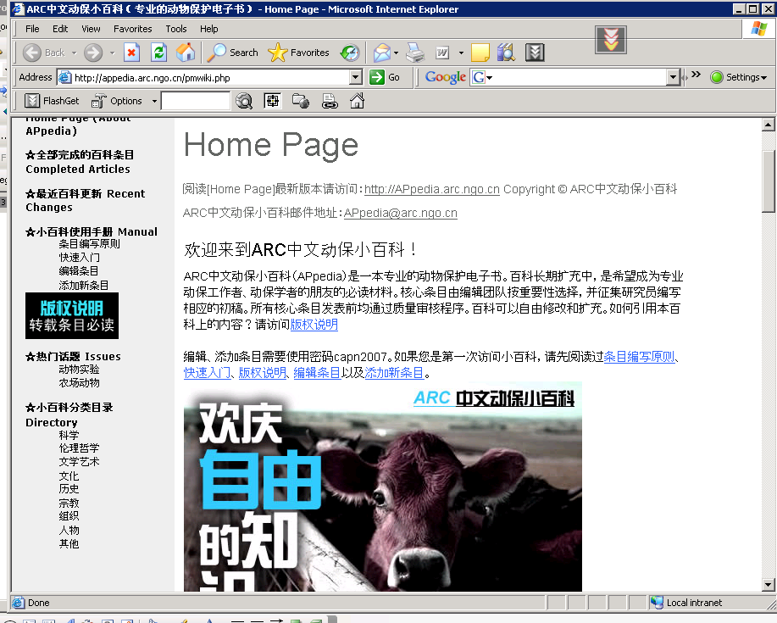

了解百科详情请访问百科网站For more information please visit APpedia website: http://appedia.arc.ngo.cn

参与国内国际动物保护会议
Taking part into national and international conference
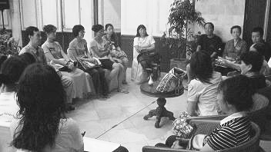
亚洲动物大会Asia for Animals conference(www.asiaforanimals.org) 详情more information: http://www.capn.ngo.cn/2008afa/

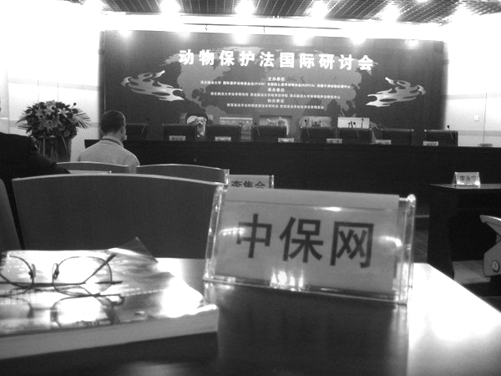
动物保护法国际研讨会 International animal law conference xi’an, China detail: http://news.xinhuanet.com/legal/2008-12/30/content_10580236.htm

2009-1-24
中国动保网
Chinese Animal Protection Network (CAPN)
Website: http://www.capn.ngo.cn


