What we have done from 2009 to 2011
Dec. 28th 2011
In the last three years, CAPN has experienced tremendous progress and growth. In this report we are going to summarize some of the most significant achievements during those 3 years. You can use Google translation or another free online translation tool to access Chinese resources mentioned in this document. The full name of the language CAPN material uses is “Chinese simplified”.
While continue its animal advocacy, CAPN has transformed into a world class research organisation for global animal protection (animal rights). Lab animal protection, farm animal protection and networking of animal activists have been major focuses during the years.
Contact CAPN: info@CAPN-online.info
Contents
Research 1
APpedia 1
Scientific surveys of Chinese attitudes towards animals 3
Lab animal protection 4
Lab animal rights petition 4
Lab animal rights group 4
World Lab Animal Days 4
Educational materials 5
Posters 5
Books 7
Video ads 7
Research database 8
Movie 8
Position documents 8
Aknowledgement 9

Research

APpedia
APpedia is a research project of CAPN, the first animal protection encyclopedia written in Chinese. It has been a focal activity of CAPN since 2009. APpedia provides comprehensive, independent and scientific research articles on major world animal protection issues. APpedia currently has more than 100 registered researchers from around world. The editorial group and authors include outstanding animal protection activists and academics.
As Chinese is one of the top-three most popular languages in the world, APpedia provides a much needed source of animal protection information for Chinese language readers, while adding balance to the eurocentrism of existing literature in the field.
APpedia is published online as a free-of-charge eBook and is a must-read for people who wish to pursue professional animal protection activism work and academic research. The content of the book includes, but is not limited to: Science, religion, events, animal behavior, philosophy, important figures, animal protection, advocacy, animal welfare, animal rights, animal protection organizations, and reviews of books.
APpedia website: http://APpedia.arc.capn-online.info
Below are some highlighted research articles from APpedia, ordered by time of completion. Those on top are the most recent. All these articles can be accessed at the APpedia website: http://APpedia.arc.capn-online.info
- Stop Huntingdon Animal Cruelty
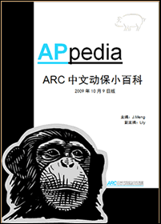
- The Controversy and Study of Animals' Capability of Feeling Pain
- Alternatives to Animal Experimentation in Education
- Animal Euthanasia
- Zoo (in A Broader Sense)
- Animal Worship and Reverence to Animals
- The Relationship Between Compassion to Humans and Compassion to Animals
- China's Lab Animal Protection Laws (National and Provincial)
- The Relativity of Animal Welfare
- International Agreements Related to Animal Protection that China is Participating in
- Animal Experimentation in Western Medicine and Traditional Medicines: An Exploration
- The Different Definitions for Animal Protection in Different Parts of the World
- Global Animal Use
- Alternatives to Animal Testing
- Autonomy of Animals
- Animal Welfare
- General Animal Protection
- Nietzsche's Animal Philosophy
- Book Review: Origins Of Attitudes Towards Animals
- Whaling Cruelty in Denmark
- The Great Ape Project
- Anthropomorphism
- Chinese Traditional Attitudes Towards Animals
- The Animal Ethics Dilemma of Desexing Companion Animals
- Animal Hoarding
- Four Stages of Cruelty
- Human-animal Study
- Primates of Cambridge University
- Chimpanzee Washoe
- Judaism and Animals
- Christianity and Animals
- Live Export
- Animal Behaviour Science
- Buddhism and Animals
- World Farm Animal Day
- Great Apes
- Islam and Animals
- Chicken Fighting
- Lab Animal Protection Regulation in the World
- Animal Liberation Front
- Animal Welfare in Nazi Germany
- In Vitro Meat
- Hinduism and Animals
- Deep Ecology
- Evolution of Altruism
- Christianity and Animals
- Vegetarianism
- World Lab Animal Day
- Animal Rights
- The Brown Dog Affair

- Farm Animals
- Animal Experimentation

Scientific surveys of Chinese attitudes towards animals
CAPN has supported, organized and distributed the results of several surveys in the last several years.
- National student survey (NSS)

Figure 1 Guangzhou, volunteers are inviting participants for NSS in
- Lab animal use in China survey (online part)
- Teacher’s attitudes to animals survey
The survey report can be downloaded at http://capn-online.info

Lab animal protection

Lab animal rights petition
CAPN launched the first Chinese lab animal rights petition in 2011: Open letter to Kunming Primate Research Center, Chinese Academy of Sciences. Chinese Academy of Sciences is a leading research institution in China. Kunming primate research centre is one of the major primate research centers in China. This petition was so far signed by more than 90 organisations and more than 5000 individuals, which forms the largest Chinese lab animal rights coalition to date. Individual signers include academics, scientists, government officers, journalists, celebrities and people working or studying in the bio-medical fields.
Web address of the petition: http://petitions.goodeasy.info/petition_capn.php?id=15
We also initiated and coordinated four other ongoing petitions in the second half of 2011; in total these petitions have received more than 1000 signatures from animal organisations and individuals. The issues those petitions cover includes: anti-breeding, support of vegetarianism, alternatives to animals in product safety tests, and animal experimentation in education. 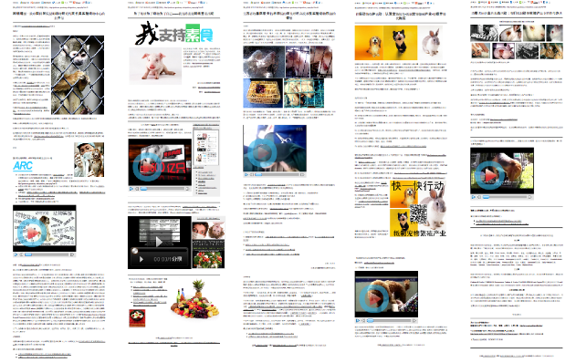
Figure 2 The five petitions

Lab animal rights group
The lab animal rights unit of CAPN, ARC lab animal group, was launched in 2008. During the last three years, it has grown into a large network of activists. The network currently includes more than three thousand Chinese speakers around the globe. Most lab animal protection activities of CAPN were carried out through this group.
More of the group's activities can be found on: http://arc.capn-online.info/wlad

World Lab Animal Days
CAPN continuously organizes an event each year in April to commemorate the World Lab Animal Day. The 2011 event was larger than ever in terms of the number organizations that have been involved.
2011 event summary: http://network.capn-online.info/index.php/2011-04-03-01-05-12/103-gedijinianshijieshiyandongwuridehuodong
Changchun student event 2011: http://network.capn-online.info/index.php/2011-04-03-01-05-12/105-jilingdaxueguanlixueyuan10ji3banshijieshiyandongwuri

Figure 3 Photos of the Changchun event

Figure 4 CAPN poster used in the event
For more information please download: Report on our efforts of lab animal protection in 2009 and 2010, May 2010, address: http://capn-online.info/WLAD2009a2010China_en.doc

Educational materials
CAPN has produced and widely distributed large amounts of high quality educational material in the last three years

Posters
- How many lab animals are killed every year?

- I have to do animal testing but I do not want to!

- Have you been nice to animals today?

- A rat's plea

- What is love?

- Peace


Books
- APpedia has been expanding http://appedia.arc.capn-online.info
- The rights and wrongs of lab animal rights: Commemorate world lab animal day. A book systematically discussing lab animal rights. Download URL
http://arc.capn-online.info/wlad/WorldLabAnimalWeek_Booklet.doc
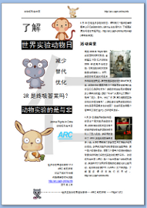 
- New edition of the book For Earth, for Animals, for Yourself: Reduce Meat Consumption. To assist the CAPN farm animal protection campaign in October 2011, CAPN published a new edition of the farm animal rights book to incorporate up-to-date research on the topic.
- An excerpt on World animal use, from ORIGINS OF ATTITUDES TOWARDS ANIMALS was released to the public domain through CAPN with the permission of the author. This excerpt can be download at: http://capn-online.info/en.php

Video ads
CAPN released four well received video advertisements for animal rights
- Dancing ants http://film.goodeasy.info/dancingants/chinese/
- 
- Please speak for the voiceless http://arc.capn-online.info/wlad

- We care about lab animals http://arc.capn-online.info/wlad
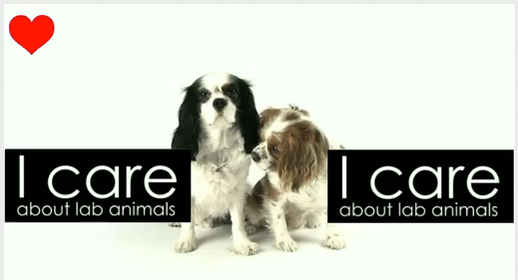

- Animal rights http://arc.capn-online.info/waw

Research database
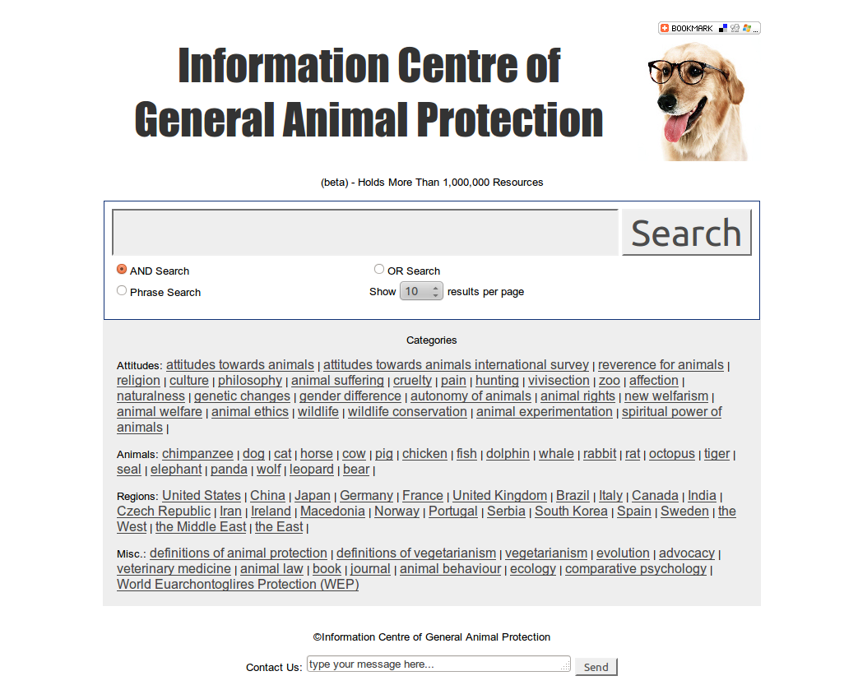
Figure 5 Screenshot of ICGAP
CAPN has provided significant contributions to the establishment of the Information Centre of General Animal Protection (ICGAP), a free and comprehensive database of general animal protection.
Website: http://AnimalProtection.GoodEasy.info

Movie
CAPN has provided significant contributions to the production of the 2011 vegetarian documentary Myths and Truths about Vegetarianism - For Earth, for Animals, for Yourself. Watch the film online http://capn-online.info/mtvfilm.php

“Myths and Truths about Vegetarianism – For Earth, for Animals, for Yourself ” is a documentary that systematically analyzes the scientific basis of claims that vegetarianism is unnatural for humans and that we require meat. After watching this, you will find out the exact opposite.

Position documents
Position documents state CAPN's opinions on different issues. CAPN has released following position documents in the last three years.
- Our position on outlawing cat and dog meat in China. May 2010
Note: our Refuse cat-dog-meat signing event is continuously expending, so far we have received more than 91,000 signatures. Petition address: http://ccapn.capn-online.info/acpetition.php
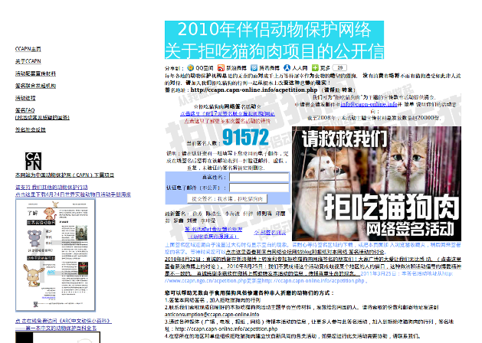
Figure 6 Screenshot of Refuse cat-dog-meat signing event

Figure 7 Volunteers from Shoushan-Guangdong promoting the petition with a local event
- FAQ (Chinese Attitudes towards Animals, Animal protection legislation in China, Animal rights movement and animal welfare movement in China etc.), July 2010
- Traditional medicines: Promising alternatives to animal experimentations, March 2011
The position documents mentioned above can be downloaded at: http://capn-online.info/en.php
- FAQ of lab animal rights. The first edition was released in mid-2011. URL: http://arc.capn-online.info/wlad
- The Animal Rights article of APpedia. The latest edition is also a major position document of CAPN. The full article can be accessed at http://appedia.arc.capn-online.info/ar
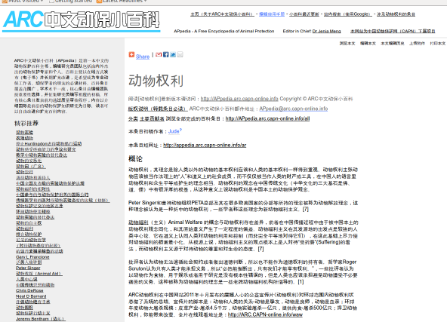
Figure 8 Screenshot of the Animal Rights article of APpedia

Aknowledgement
CAPN would like to say thank you to all organizations and individuals who have helped our animal protection work from 2009 to 2011

